what is sprint planning Meeting?
A Sprint Planning Meeting is an event in the Agile Scrum framework where the Scrum Team decides what work will be completed during the upcoming sprint (a fixed development period, usually 1–4 weeks) and how that work will be accomplished.
Purpose
The meeting helps the team:
- Define the Sprint Goal (the objective for the sprint).
- Select items from the Product Backlog to work on.
- Create a Sprint Backlog (the list of tasks for the sprint).
- Estimate effort and plan the work.
Participants
- Product Owner – explains priorities and requirements.
- Scrum Master – facilitates the meeting and ensures Scrum practices are followed.
- Development Team – estimates work and commits to sprint tasks.

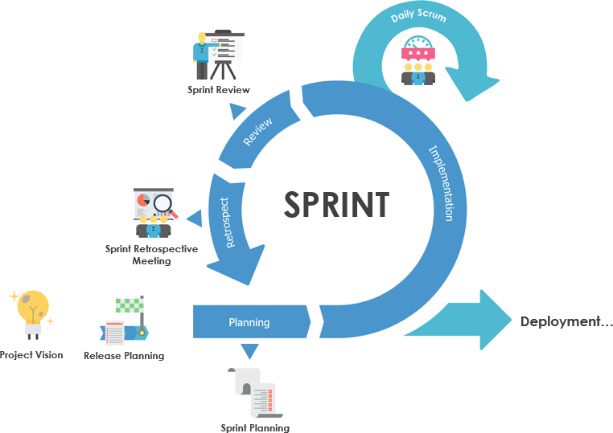

Typical Agenda
- Review Product Backlog
  - Discuss the highest-priority backlog items.
- Set Sprint Goal
  - Agree on the main objective for the sprint.
- Select Work
  - Choose backlog items the team can realistically complete.
- Break Down Tasks
  - Divide selected items into smaller tasks.
- Confirm Commitment
  - Ensure everyone understands and agrees on the plan.
Example
Suppose a team is building an e-commerce website.
Sprint Goal: Improve the checkout process.
Selected Backlog Items:
- Add online payment integration.
- Improve checkout page design.
- Fix checkout-related bugs.
The team then estimates and assigns tasks needed to complete these items during the sprint.
Duration
A common guideline is:
- For a 2-week sprint: about 2–4 hours
- For a 1-month sprint: up to 8 hours
Output
By the end of the Sprint Planning Meeting, the team should have:
- A clear Sprint Goal
- A prioritized Sprint Backlog
- A shared understanding of how the work will be delivered
In short, Sprint Planning is the meeting where the Scrum team decides what they will deliver in the next sprint and creates a plan to achieve it.
what is Retrospective meeting?
A Retrospective Meeting (also called a Sprint Retrospective) is an Agile Scrum meeting held at the end of every sprint. Its purpose is to help the team reflect on the sprint and identify ways to improve how they work together in the next sprint.
Purpose
The team discusses:
- What went well?
- What didn't go well?
- What can be improved?
- What actions should be taken in the next sprint?
The goal is continuous improvement, not assigning blame.
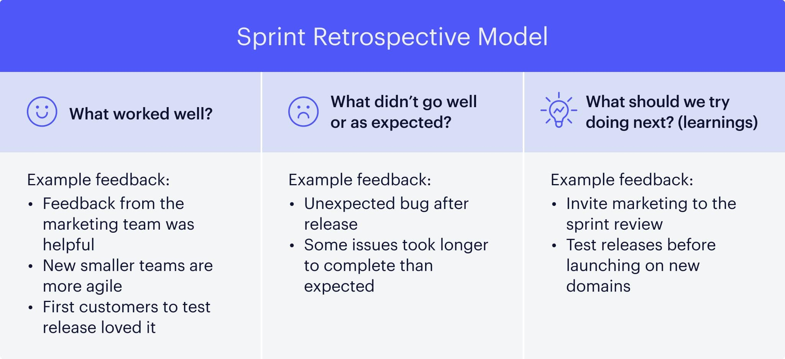
Participants
- Scrum Master – facilitates the discussion.
- Product Owner – participates and provides feedback.
- Development Team – shares experiences and improvement ideas.
Typical Agenda
- Review the Sprint
  - Briefly discuss what happened during the sprint.
- Discuss What Went Well
  - Good teamwork
  - Tasks completed on time
  - Successful testing or deployment
- Discuss Challenges
  - Delays
  - Communication issues
  - Technical problems
  - Requirement changes
- Identify Improvements
  - Decide on practical actions for the next sprint.
- Create Action Items
  - Assign improvements to implement in the upcoming sprint.
Example
Suppose the sprint was to build a login module.
What went well
- Login feature completed on time.
- Good collaboration between developers and testers.
- No critical production bugs.
What didn't go well
- Requirements changed midway through the sprint.
- Code reviews took longer than expected.
- Some tasks were underestimated.
Improvements
- Clarify requirements before development starts.
- Schedule code reviews daily.
- Break large user stories into smaller tasks.
Duration
Typical timeboxes are:
- 2-week sprint: 1–1.5 hours
- 4-week sprint: Up to 3 hours
Output
By the end of the Retrospective, the team should have:
- A list of lessons learned.
- Specific improvement actions.
- Agreement on changes to try in the next sprint.
Difference Between Sprint Planning and Retrospective
Sprint Planning | Sprint Retrospective
Happens before the sprint | Happens after the sprint
Plans the upcoming work | Reviews the completed sprint
Focuses on what to build and how | Focuses on how the team worked
Output: Sprint Goal and Sprint Backlog | Output: Improvement action items
what is daily standup meeting?
A Daily Standup Meeting (also called the Daily Scrum) is a short meeting held every working day during a sprint. Its purpose is to help the team stay aligned, share progress, and identify any blockers.
The meeting is called a standup because teams traditionally stand during it to keep it brief and focused.
Purpose
The Daily Standup helps the team:
- Share progress on their work.
- Coordinate with teammates.
- Identify obstacles that need to be resolved.
- Stay focused on the Sprint Goal.
Participants
- Development Team – required participants who share updates.
- Scrum Master – ensures the meeting stays focused and removes impediments afterward.
- Product Owner – may attend but is not required.
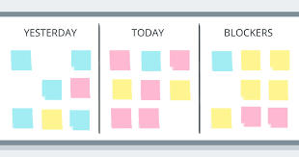
Three Common Questions
Each team member typically answers these questions:
- What did I complete yesterday?
- What will I work on today?
- Are there any blockers or issues preventing my progress?
Example
Developer A
- Yesterday: Completed the login API.
- Today: Start user registration API.
- Blockers: None.
Developer B
- Yesterday: Tested the payment module.
- Today: Verify bug fixes.
- Blockers: Waiting for updated test data.
Tester
- Yesterday: Logged five defects.
- Today: Retest fixed bugs.
- Blockers: Test environment is unavailable.
Duration
- Usually 15 minutes or less.
- Held at the same time and place every day during the sprint.
Rules
- Keep updates short and relevant.
- Focus on progress toward the Sprint Goal.
- Avoid solving problems during the meeting—schedule follow-up discussions if needed.
- Everyone should have a chance to speak.
Output
By the end of the Daily Standup, the team should have:
- A shared understanding of everyone's progress.
- Awareness of blockers.
- A clear plan for the day's work.

